**Table S1. SGAtool analyzed the scores of each knockout strain under HMF conditions**

|  |  |  |  |  |  |  |  |  |  |
| --- | --- | --- | --- | --- | --- | --- | --- | --- | --- |
| NO | Array ORF | Array Name | Normalized colony size (EXPERIMENT) | Normalized colony std. dev. (EXPERIMENT) | Normalized colony size (CONTROL) | Normalized colony std. dev. (CONTROL) | Score | Score stdev | p-Value |
| 1 | *YMR283C* | *RIT1* | 0.38 | 0.01 | 1.04 | 0.03 | -0.66 | 0.01 | 0.00 |
| 2 | *YDR049W* | *VMS1* | 0.38 | 0.00 | 0.98 | 0.02 | -0.60 | 0.00 | 0.00 |
| 3 | *YJR075W* | *HOC1* | 0.69 | 0.01 | 1.21 | 0.02 | -0.52 | 0.01 | 0.00 |
| 4 | *YBL047C* | *EDE1* | 0.40 | 0.02 | 0.92 | 0.01 | -0.52 | 0.02 | 0.00 |
| 5 | *YDR068W* | *DOS2* | 0.42 | 0.04 | 0.94 | 0.02 | -0.52 | 0.04 | 0.00 |
| 6 | *YGL105W* | *ARC1* | 0.27 | 0.01 | 0.78 | 0.00 | -0.51 | 0.01 | 0.00 |
| 7 | *YHR030C* | *SLT2* | 0.80 | 0.05 | 1.29 | 0.05 | -0.48 | 0.05 | 0.00 |
| 8 | *YOR191W* | *ULS1* | 0.65 | 0.02 | 1.11 | 0.03 | -0.46 | 0.02 | 0.00 |
| 9 | *YMR272C* | *SCS7* | 0.61 | 0.07 | 1.06 | 0.02 | -0.45 | 0.07 | 0.00 |
| 10 | *YJL124C* | *LSM1* | 0.43 | 0.02 | 0.88 | 0.03 | -0.45 | 0.02 | 0.00 |
| 11 | *YDR360W* | *YDR360W* | 0.62 | 0.02 | 1.05 | 0.00 | -0.43 | 0.02 | 0.00 |
| 12 | *YNL032W* | *SIW14* | 0.72 | 0.02 | 1.12 | 0.12 | -0.42 | 0.02 | 0.00 |
| 13 | *YML035C* | *AMD1* | 0.51 | 0.01 | 0.93 | 0.04 | -0.41 | 0.01 | 0.00 |
| 14 | *YBR025C* | *OLA1* | 0.55 | 0.01 | 0.96 | 0.01 | -0.41 | 0.01 | 0.00 |
| 15 | *YDR378C* | *LSM6* | 0.29 | 0.02 | 0.69 | 0.03 | -0.40 | 0.02 | 0.00 |
| 16 | *YNR051C* | *BRE5* | 0.64 | 0.00 | 1.05 | 0.02 | -0.40 | 0.00 | 0.00 |
| 17 | *YLR217W* | *YLR217W* | 0.94 | 0.02 | 1.35 | 0.03 | -0.39 | 0.02 | 0.00 |
| 18 | *YJL121C* | *RPE1* | 0.37 | 0.05 | 0.75 | 0.05 | -0.39 | 0.05 | 0.00 |
| 19 | *YMR275C* | *BUL1* | 0.66 | 0.03 | 1.02 | 0.04 | -0.37 | 0.03 | 0.00 |
| 20 | *YKL023W* | *YKL023W* | 0.64 | 0.04 | 1.01 | 0.03 | -0.36 | 0.04 | 0.00 |
| 21 | *YNR005C* | *YNR005C* | 0.74 | 0.01 | 1.09 | 0.06 | -0.35 | 0.01 | 0.00 |
| 22 | *YLR085C* | *ARP6* | 0.67 | 0.00 | 1.03 | 0.04 | -0.34 | 0.00 | 0.00 |
| 23 | *YML041C* | *VPS71* | 0.63 | 0.04 | 0.98 | 0.04 | -0.34 | 0.04 | 0.00 |
| 24 | *YJR059W* | *PTK2* | 0.49 | 0.04 | 0.83 | 0.02 | -0.34 | 0.04 | 0.00 |
| 25 | *YNL136W* | *EAF7* | 0.45 | 0.02 | 0.78 | 0.03 | -0.33 | 0.02 | 0.00 |
| 26 | *YJL136C* | *RPS21B* | 0.60 | 0.06 | 0.92 | 0.02 | -0.32 | 0.06 | 0.00 |
| 27 | *YLR330W* | *CHS5* | 0.85 | 0.03 | 1.16 | 0.04 | -0.32 | 0.03 | 0.00 |
| 28 | *YCR053W* | *THR4* | 0.65 | 0.02 | 0.97 | 0.01 | -0.31 | 0.02 | 0.00 |
| 29 | *YNL099C* | *OCA1* | 0.78 | 0.01 | 1.09 | 0.03 | -0.31 | 0.01 | 0.00 |
| 30 | *YGL084C* | *GUP1* | 0.51 | 0.01 | 0.80 | 0.01 | -0.30 | 0.01 | 0.00 |
| 31 | *YDL078C* | *MDH3* | 0.91 | 0.03 | 1.21 | 0.04 | -0.30 | 0.03 | 0.00 |
| 32 | *YOR006C* | *TSR3* | 0.86 | 0.05 | 1.16 | 0.06 | -0.30 | 0.05 | 0.00 |
| 33 | *YDR067C* | *OCA6* | 0.73 | 0.02 | 1.03 | 0.03 | -0.30 | 0.02 | 0.00 |
| 34 | *YER151C* | *UBP3* | 0.73 | 0.01 | 1.02 | 0.01 | -0.29 | 0.01 | 0.00 |
| 35 | *YNL229C* | *URE2* | 0.69 | 0.02 | 0.98 | 0.01 | -0.29 | 0.02 | 0.00 |

**Table S1. SGAtool analyzed the scores of each knockout strain under HMF conditions (Continue)**

|  |  |  |  |  |  |  |  |  |  |
| --- | --- | --- | --- | --- | --- | --- | --- | --- | --- |
| NO | Array ORF | Array Name | Normalized colony size (EXPERIMENT) | Normalized colony std. dev. (EXPERIMENT) | Normalized colony size (CONTROL) | Normalized colony std. dev. (CONTROL) | Score | Score stdev | p-Value |
| 36 | *YPR134W* | *MSS18* | 0.55 | 0.02 | 0.84 | 0.00 | -0.29 | 0.02 | 0.00 |
| 37 | *YPR024W* | *YME1* | 0.56 | 0.01 | 0.84 | 0.02 | -0.28 | 0.01 | 0.00 |
| 38 | *YKL046C* | *DCW1* | 0.94 | 0.09 | 1.22 | 0.05 | -0.28 | 0.09 | 0.00 |
| 39 | *YHR086W* | *NAM8* | 0.75 | 0.04 | 1.02 | 0.03 | -0.28 | 0.04 | 0.00 |
| 40 | *YDL050C* | *YDL050C* | 0.74 | 0.00 | 1.01 | 0.01 | -0.27 | 0.00 | 0.00 |
| 41 | *YML008C* | *ERG6* | 0.50 | 0.02 | 0.77 | 0.02 | -0.27 | 0.02 | 0.00 |
| 42 | *YNL147W* | *LSM7* | 0.51 | 0.05 | 0.78 | 0.04 | -0.27 | 0.05 | 0.00 |
| 43 | *YGR038W* | *ORM1* | 0.93 | 0.01 | 1.20 | 0.03 | -0.26 | 0.01 | 0.00 |
| 44 | *YNL254C* | *RTC4* | 0.82 | 0.05 | 1.08 | 0.02 | -0.26 | 0.05 | 0.00 |
| 45 | *YPL183C* | *RTT10* | 0.73 | 0.00 | 0.99 | 0.02 | -0.26 | 0.00 | 0.00 |
| 46 | *YMR026C* | *PEX12* | 0.78 | 0.03 | 1.02 | 0.05 | -0.25 | 0.03 | 0.00 |
| 47 | *YBL094C* | *YBL094C* | 0.71 | 0.01 | 0.96 | 0.07 | -0.25 | 0.01 | 0.00 |
| 48 | *YDR485C* | *VPS72* | 0.67 | 0.01 | 0.92 | 0.00 | -0.25 | 0.01 | 0.00 |
| 49 | *YJL062W* | *LAS21* | 0.74 | 0.02 | 0.99 | 0.01 | -0.25 | 0.02 | 0.00 |
| 50 | *YOR012W* | *YOR012W* | 0.76 | 0.02 | 1.00 | 0.01 | -0.25 | 0.02 | 0.00 |
| 51 | *YHR078W* | *YHR078W* | 0.85 | 0.03 | 1.09 | 0.01 | -0.24 | 0.03 | 0.00 |
| 52 | *YNL008C* | *ASI3* | 0.95 | 0.03 | 1.19 | 0.05 | -0.24 | 0.03 | 0.00 |
| 53 | *YFL023W* | *BUD27* | 0.64 | 0.03 | 0.88 | 0.03 | -0.24 | 0.03 | 0.00 |
| 54 | *YJR082C* | *EAF6* | 0.78 | 0.02 | 1.02 | 0.02 | -0.24 | 0.02 | 0.00 |
| 55 | *YNL072W* | *RNH201* | 0.76 | 0.03 | 1.00 | 0.02 | -0.24 | 0.03 | 0.00 |
| 56 | *YMR282C* | *AEP2* | 0.78 | 0.02 | 1.01 | 0.04 | -0.23 | 0.02 | 0.00 |
| 57 | *YLR452C* | *SST2* | 0.99 | 0.02 | 1.23 | 0.02 | -0.23 | 0.02 | 0.00 |
| 58 | *YBR001C* | *NTH2* | 0.74 | 0.02 | 0.97 | 0.00 | -0.23 | 0.02 | 0.00 |
| 59 | *YNL089C* | *YNL089C* | 0.85 | 0.02 | 1.08 | 0.02 | -0.23 | 0.02 | 0.00 |
| 60 | *YMR031W-A* | *YMR031W-A* | 0.59 | 0.03 | 0.83 | 0.03 | -0.23 | 0.03 | 0.00 |
| 61 | *YLR332W* | *MID2* | 0.92 | 0.05 | 1.14 | 0.04 | -0.23 | 0.05 | 0.00 |
| 62 | *YHR066W* | *SSF1* | 0.77 | 0.01 | 1.00 | 0.01 | -0.23 | 0.01 | 0.00 |
| 63 | *YBL007C* | *SLA1* | 0.64 | 0.01 | 0.87 | 0.03 | -0.23 | 0.01 | 0.00 |
| 64 | *YJR074W* | *MOG1* | 0.64 | 0.05 | 0.87 | 0.03 | -0.23 | 0.05 | 0.00 |
| 65 | *YDR304C* | *CPR5* | 0.88 | 0.01 | 1.11 | 0.03 | -0.23 | 0.01 | 0.00 |
| 66 | *YLR098C* | *CHA4* | 0.89 | 0.01 | 1.12 | 0.04 | -0.23 | 0.01 | 0.00 |
| 67 | *YIL132C* | *CSM2* | 0.91 | 0.07 | 1.13 | 0.03 | -0.22 | 0.07 | 0.00 |
| 68 | *YLR070C* | *XYL2* | 0.94 | 0.06 | 1.17 | 0.05 | -0.22 | 0.06 | 0.00 |
| 69 | *YMR318C* | *ADH6* | 0.81 | 0.02 | 1.03 | 0.02 | -0.22 | 0.02 | 0.00 |
| 70 | *YDR532C* | *KRE28* | 0.57 | 0.01 | 0.79 | 0.02 | -0.22 | 0.01 | 0.00 |

**Table S1. SGAtool analyzed the scores of each knockout strain under HMF conditions (Continue)**

|  |  |  |  |  |  |  |  |  |  |
| --- | --- | --- | --- | --- | --- | --- | --- | --- | --- |
| NO | Array ORF | Array Name | Normalized colony size (EXPERIMENT) | Normalized colony std. dev. (EXPERIMENT) | Normalized colony size (CONTROL) | Normalized colony std. dev. (CONTROL) | Score | Score stdev | p-Value |
| 71 | *YJR097W* | *JJJ3* | 0.70 | 0.03 | 0.93 | 0.03 | -0.22 | 0.03 | 0.00 |
| 72 | *YJL211C* | *YJL211C* | 0.89 | 0.04 | 1.10 | 0.05 | -0.22 | 0.04 | 0.00 |
| 73 | *YGR051C* | *YGR051C* | 0.97 | 0.02 | 1.19 | 0.11 | -0.22 | 0.02 | 0.00 |
| 74 | *YFL013C* | *IES1* | 0.87 | 0.03 | 1.09 | 0.05 | -0.22 | 0.03 | 0.00 |
| 75 | *YDR334W* | *SWR1* | 0.72 | 0.01 | 0.94 | 0.03 | -0.22 | 0.01 | 0.00 |
| 76 | *YHR110W* | *ERP5* | 0.90 | 0.02 | 1.12 | 0.00 | -0.22 | 0.02 | 0.00 |
| 77 | *YHL024W* | *RIM4* | 0.92 | 0.01 | 1.13 | 0.01 | -0.21 | 0.01 | 0.00 |
| 78 | *YGR055W* | *MUP1* | 0.62 | 0.02 | 0.84 | 0.04 | -0.21 | 0.02 | 0.00 |
| 79 | *YCL009C* | *ILV6* | 0.94 | 0.04 | 1.15 | 0.04 | -0.21 | 0.04 | 0.00 |
| 80 | *YLL046C* | *RNP1* | 0.98 | 0.00 | 1.21 | 0.10 | -0.21 | 0.00 | 0.00 |
| 81 | *YCR085W* | *YCR085W* | 0.81 | 0.02 | 1.01 | 0.02 | -0.21 | 0.02 | 0.00 |
| 82 | *YHL023C* | *NPR3* | 0.83 | 0.01 | 1.04 | 0.03 | -0.21 | 0.01 | 0.00 |
| 83 | *YJL141C* | *YAK1* | 0.84 | 0.10 | 1.04 | 0.03 | -0.21 | 0.10 | 0.00 |
| 84 | *YCR062W* | *YCR062W* | 0.86 | 0.03 | 1.08 | 0.03 | -0.21 | 0.03 | 0.00 |
| 85 | *YPL213W* | *LEA1* | 0.67 | 0.01 | 0.88 | 0.02 | -0.20 | 0.01 | 0.00 |
| 86 | *YGL059W* | *PKP2* | 0.97 | 0.04 | 1.18 | 0.01 | -0.20 | 0.04 | 0.00 |
| 87 | *YBL024W* | *NCL1* | 0.77 | 0.02 | 0.97 | 0.00 | -0.20 | 0.02 | 0.00 |
| 88 | *YKR084C* | *HBS1* | 0.67 | 0.03 | 0.88 | 0.02 | -0.20 | 0.03 | 0.00 |
| 89 | *YPL105C* | *SYH1* | 0.89 | 0.01 | 1.09 | 0.01 | -0.20 | 0.01 | 0.00 |
| 90 | *YGR122C-A* | *YGR122C-A* | 0.98 | 0.02 | 1.19 | 0.04 | -0.20 | 0.02 | 0.00 |
| 91 | *YDL051W* | *LHP1* | 0.80 | 0.02 | 1.00 | 0.01 | -0.20 | 0.02 | 0.00 |
| 92 | *YMR163C* | *INP2* | 0.81 | 0.01 | 1.01 | 0.02 | -0.20 | 0.01 | 0.00 |
| 93 | *YDL091C* | *UBX3* | 1.21 | 0.03 | 1.01 | 0.01 | 0.20 | 0.03 | 0.00 |
| 94 | *YKR019C* | *IRS4* | 1.19 | 0.05 | 0.99 | 0.01 | 0.20 | 0.05 | 0.00 |
| 95 | *YGL014W* | *PUF4* | 1.24 | 0.05 | 1.04 | 0.01 | 0.20 | 0.05 | 0.00 |
| 96 | *YOR108W* | *LEU9* | 1.15 | 0.05 | 0.94 | 0.01 | 0.20 | 0.05 | 0.00 |
| 97 | *YDR032C* | *PST2* | 1.17 | 0.03 | 0.97 | 0.02 | 0.20 | 0.03 | 0.00 |
| 98 | *YJR014W* | *TMA22* | 1.11 | 0.01 | 0.90 | 0.02 | 0.20 | 0.01 | 0.00 |
| 99 | *YOL081W* | *IRA2* | 1.03 | 0.08 | 0.82 | 0.02 | 0.20 | 0.08 | 0.00 |
| 100 | *YIL085C* | *KTR7* | 1.03 | 0.01 | 0.83 | 0.01 | 0.20 | 0.01 | 0.00 |
| 101 | *YER066W* | *RRT13* | 1.17 | 0.05 | 0.97 | 0.01 | 0.20 | 0.05 | 0.00 |
| 102 | *YGR183C* | *QCR9* | 1.07 | 0.01 | 0.86 | 0.04 | 0.20 | 0.01 | 0.00 |
| 103 | *YGL180W* | *ATG1* | 1.22 | 0.06 | 1.01 | 0.03 | 0.21 | 0.06 | 0.00 |
| 104 | *YLR177W* | *YLR177W* | 1.14 | 0.01 | 0.93 | 0.02 | 0.21 | 0.01 | 0.00 |
| 105 | *YCR009C* | *RVS161* | 1.05 | 0.03 | 0.84 | 0.01 | 0.21 | 0.03 | 0.00 |

**Table S1. SGAtool analyzed the scores of each knockout strain under HMF conditions (Continue)**

|  |  |  |  |  |  |  |  |  |  |
| --- | --- | --- | --- | --- | --- | --- | --- | --- | --- |
| NO | Array ORF | Array Name | Normalized colony size (EXPERIMENT) | Normalized colony std. dev. (EXPERIMENT) | Normalized colony size (CONTROL) | Normalized colony std. dev. (CONTROL) | Score | Score stdev | p-Value |
| 106 | *YKR031C* | *SPO14* | 1.23 | 0.02 | 1.02 | 0.00 | 0.21 | 0.02 | 0.00 |
| 107 | *YML026C* | *RPS18B* | 1.04 | 0.02 | 0.84 | 0.02 | 0.21 | 0.02 | 0.00 |
| 108 | *YLR407W* | *YLR407W* | 1.08 | 0.00 | 0.87 | 0.03 | 0.21 | 0.00 | 0.00 |
| 109 | *YJR010C-A* | *SPC1* | 1.24 | 0.06 | 1.03 | 0.01 | 0.22 | 0.06 | 0.00 |
| 110 | *YBL104C* | *SEA4* | 1.11 | 0.01 | 0.89 | 0.01 | 0.22 | 0.01 | 0.00 |
| 111 | *YDL232W* | *OST4* | 0.91 | 0.05 | 0.70 | 0.01 | 0.22 | 0.05 | 0.00 |
| 112 | *YIL138C* | *TPM2* | 1.27 | 0.02 | 1.06 | 0.03 | 0.22 | 0.02 | 0.00 |
| 113 | *YGR105W* | *VMA21* | 1.04 | 0.02 | 0.83 | 0.02 | 0.22 | 0.02 | 0.00 |
| 114 | *YGR161C* | *RTS3* | 1.12 | 0.01 | 0.90 | 0.01 | 0.22 | 0.01 | 0.00 |
| 115 | *YBR141C* | *YBR141C* | 1.19 | 0.01 | 0.97 | 0.01 | 0.22 | 0.01 | 0.00 |
| 116 | *YKL146W* | *AVT3* | 1.15 | 0.02 | 0.94 | 0.02 | 0.22 | 0.02 | 0.00 |
| 117 | *YLR179C* | *YLR179C* | 1.26 | 0.04 | 1.05 | 0.04 | 0.22 | 0.04 | 0.00 |
| 118 | *YBR082C* | *UBC4* | 1.14 | 0.02 | 0.92 | 0.01 | 0.22 | 0.02 | 0.00 |
| 119 | *YEL057C* | *YEL057C* | 1.16 | 0.02 | 0.94 | 0.01 | 0.22 | 0.02 | 0.00 |
| 120 | *YCL036W* | *GFD2* | 1.20 | 0.04 | 0.98 | 0.01 | 0.22 | 0.04 | 0.00 |
| 121 | *YDR209C* | *YDR209C* | 1.30 | 0.01 | 1.08 | 0.03 | 0.22 | 0.01 | 0.00 |
| 122 | *YKL073W* | *LHS1* | 0.97 | 0.23 | 0.72 | 0.15 | 0.22 | 0.23 | 0.00 |
| 123 | *YKL048C* | *ELM1* | 0.92 | 0.06 | 0.70 | 0.02 | 0.22 | 0.06 | 0.00 |
| 124 | *YML004C* | *GLO1* | 1.21 | 0.01 | 0.98 | 0.01 | 0.22 | 0.01 | 0.00 |
| 125 | *YLR371W* | *ROM2* | 1.15 | 0.04 | 0.93 | 0.01 | 0.22 | 0.04 | 0.00 |
| 126 | *YOR183W* | *FYV12* | 1.10 | 0.01 | 0.87 | 0.01 | 0.23 | 0.01 | 0.00 |
| 127 | *YLR176C* | *RFX1* | 1.27 | 0.03 | 1.05 | 0.01 | 0.23 | 0.03 | 0.00 |
| 128 | *YAL022C* | *FUN26* | 1.17 | 0.09 | 0.92 | 0.07 | 0.23 | 0.09 | 0.00 |
| 129 | *YKR020W* | *VPS51* | 1.28 | 0.03 | 1.05 | 0.01 | 0.23 | 0.03 | 0.00 |
| 130 | *YHR162W* | *MPC2* | 1.02 | 0.04 | 0.79 | 0.02 | 0.23 | 0.04 | 0.00 |
| 131 | *YKL174C* | *TPO5* | 1.21 | 0.03 | 0.98 | 0.02 | 0.23 | 0.03 | 0.00 |
| 132 | *YLR384C* | *IKI3* | 1.10 | 0.02 | 0.87 | 0.00 | 0.23 | 0.02 | 0.00 |
| 133 | *YOR193W* | *PEX27* | 1.18 | 0.01 | 0.95 | 0.01 | 0.23 | 0.01 | 0.00 |
| 134 | *YNL171C* | *YNL171C* | 1.05 | 0.01 | 0.82 | 0.02 | 0.23 | 0.01 | 0.00 |
| 135 | *YDR508C* | *GNP1* | 1.26 | 0.02 | 1.03 | 0.01 | 0.23 | 0.02 | 0.00 |
| 136 | *YPR018W* | *RLF2* | 1.12 | 0.04 | 0.89 | 0.02 | 0.23 | 0.04 | 0.00 |
| 137 | *YIR019C* | *FLO11* | 1.25 | 0.10 | 1.03 | 0.04 | 0.23 | 0.10 | 0.00 |
| 138 | *YLR443W* | *ECM7* | 1.14 | 0.00 | 0.92 | 0.03 | 0.23 | 0.00 | 0.00 |
| 139 | *YNL170W* | *YNL170W* | 0.90 | 0.03 | 0.66 | 0.02 | 0.23 | 0.03 | 0.00 |
| 140 | *YML097C* | *VPS9* | 1.17 | 0.01 | 0.93 | 0.02 | 0.23 | 0.01 | 0.00 |

**Table S1. SGAtool analyzed the scores of each knockout strain under HMF conditions (Continue)**

|  |  |  |  |  |  |  |  |  |  |
| --- | --- | --- | --- | --- | --- | --- | --- | --- | --- |
| NO | Array ORF | Array Name | Normalized colony size (EXPERIMENT) | Normalized colony std. dev. (EXPERIMENT) | Normalized colony size (CONTROL) | Normalized colony std. dev. (CONTROL) | Score | Score stdev | p-Value |
| 141 | *YGR078C* | *PAC10* | 1.10 | 0.03 | 0.88 | 0.05 | 0.23 | 0.03 | 0.00 |
| 142 | *YOR182C* | *RPS30B* | 1.12 | 0.01 | 0.88 | 0.01 | 0.23 | 0.01 | 0.00 |
| 143 | *YMR145C* | *NDE1* | 1.23 | 0.07 | 0.99 | 0.02 | 0.23 | 0.07 | 0.00 |
| 144 | *YDL076C* | *RXT3* | 1.19 | 0.00 | 0.96 | 0.04 | 0.24 | 0.00 | 0.00 |
| 145 | *YKR047W* | *YKR047W* | 1.22 | 0.02 | 0.97 | 0.04 | 0.24 | 0.02 | 0.00 |
| 146 | *YMR029C* | *FAR8* | 1.19 | 0.04 | 0.96 | 0.02 | 0.24 | 0.04 | 0.00 |
| 147 | *YBR095C* | *RXT2* | 1.11 | 0.02 | 0.87 | 0.00 | 0.24 | 0.02 | 0.00 |
| 148 | *YNR029C* | *YNR029C* | 1.10 | 0.01 | 0.86 | 0.04 | 0.24 | 0.01 | 0.00 |
| 149 | *YMR271C* | *URA10* | 1.21 | 0.07 | 0.96 | 0.04 | 0.24 | 0.07 | 0.00 |
| 150 | *YLR327C* | *TMA10* | 1.16 | 0.03 | 0.91 | 0.03 | 0.24 | 0.03 | 0.00 |
| 151 | *YGL149W* | *YGL149W* | 1.21 | 0.02 | 0.98 | 0.02 | 0.24 | 0.02 | 0.00 |
| 152 | *YKL164C* | *PIR1* | 1.16 | 0.06 | 0.93 | 0.05 | 0.24 | 0.06 | 0.00 |
| 153 | *YML128C* | *MSC1* | 1.24 | 0.02 | 1.00 | 0.02 | 0.24 | 0.02 | 0.00 |
| 154 | *YDR156W* | *RPA14* | 1.34 | 0.03 | 1.10 | 0.03 | 0.24 | 0.03 | 0.00 |
| 155 | *YDL074C* | *BRE1* | 0.97 | 0.00 | 0.73 | 0.03 | 0.24 | 0.00 | 0.00 |
| 156 | *YMR039C* | *SUB1* | 1.28 | 0.08 | 1.04 | 0.02 | 0.24 | 0.08 | 0.00 |
| 157 | *YBR105C* | *VID24* | 0.95 | 0.01 | 0.71 | 0.00 | 0.24 | 0.01 | 0.00 |
| 158 | *YPL086C* | *ELP3* | 1.04 | 0.04 | 0.80 | 0.00 | 0.25 | 0.04 | 0.00 |
| 159 | *YDR469W* | *SDC1* | 1.09 | 0.01 | 0.85 | 0.01 | 0.25 | 0.01 | 0.00 |
| 160 | *YKL092C* | *BUD2* | 1.20 | 0.03 | 0.95 | 0.01 | 0.25 | 0.03 | 0.00 |
| 161 | *YPL071C* | *YPL071C* | 1.04 | 0.02 | 0.80 | 0.01 | 0.25 | 0.02 | 0.00 |
| 162 | *YLR287C-A* | *RPS30A* | 1.17 | 0.04 | 0.92 | 0.03 | 0.25 | 0.04 | 0.00 |
| 163 | *YOR078W* | *BUD21* | 1.04 | 0.01 | 0.79 | 0.01 | 0.25 | 0.01 | 0.00 |
| 164 | *YBR181C* | *RPS6B* | 1.18 | 0.00 | 0.93 | 0.01 | 0.25 | 0.00 | 0.00 |
| 165 | *YKR023W* | *YKR023W* | 1.21 | 0.01 | 0.97 | 0.01 | 0.25 | 0.01 | 0.00 |
| 166 | *YLR015W* | *BRE2* | 1.16 | 0.03 | 0.91 | 0.00 | 0.25 | 0.03 | 0.00 |
| 167 | *YMR312W* | *ELP6* | 1.07 | 0.02 | 0.82 | 0.02 | 0.25 | 0.02 | 0.00 |
| 168 | *YMR152W* | *YIM1* | 1.16 | 0.05 | 0.91 | 0.01 | 0.25 | 0.05 | 0.00 |
| 169 | *YGL179C* | *TOS3* | 1.22 | 0.02 | 0.97 | 0.01 | 0.25 | 0.02 | 0.00 |
| 170 | *YFL030W* | *AGX1* | 1.12 | 0.03 | 0.86 | 0.03 | 0.26 | 0.03 | 0.00 |
| 171 | *YKL109W* | *HAP4* | 1.11 | 0.05 | 0.86 | 0.01 | 0.26 | 0.05 | 0.00 |
| 172 | *YHR200W* | *RPN10* | 1.16 | 0.06 | 0.90 | 0.01 | 0.26 | 0.06 | 0.00 |
| 173 | *YIL154C* | *IMP2'* | 1.23 | 0.01 | 0.97 | 0.01 | 0.26 | 0.01 | 0.00 |
| 174 | *YLR024C* | *UBR2* | 1.21 | 0.04 | 0.95 | 0.03 | 0.26 | 0.04 | 0.00 |
| 175 | *YNL224C* | *SQS1* | 1.19 | 0.02 | 0.93 | 0.03 | 0.26 | 0.02 | 0.00 |

**Table S1. SGAtool analyzed the scores of each knockout strain under HMF conditions (Continue)**

|  |  |  |  |  |  |  |  |  |  |
| --- | --- | --- | --- | --- | --- | --- | --- | --- | --- |
| NO | Array ORF | Array Name | Normalized colony size (EXPERIMENT) | Normalized colony std. dev. (EXPERIMENT) | Normalized colony size (CONTROL) | Normalized colony std. dev. (CONTROL) | Score | Score stdev | p-Value |
| 176 | *YML035C-A* | *YML035C-A* | 1.24 | 0.02 | 0.98 | 0.02 | 0.26 | 0.02 | 0.00 |
| 177 | *YHR194W* | *MDM31* | 0.93 | 0.01 | 0.67 | 0.02 | 0.26 | 0.01 | 0.00 |
| 178 | *YDR459C* | *PFA5* | 1.14 | 0.02 | 0.88 | 0.04 | 0.26 | 0.02 | 0.00 |
| 179 | *YMR067C* | *UBX4* | 1.08 | 0.04 | 0.82 | 0.02 | 0.26 | 0.04 | 0.00 |
| 180 | *YLR320W* | *MMS22* | 1.07 | 0.01 | 0.81 | 0.01 | 0.26 | 0.01 | 0.00 |
| 181 | *YDR466W* | *PKH3* | 1.17 | 0.01 | 0.91 | 0.02 | 0.26 | 0.01 | 0.00 |
| 182 | *YHR059W* | *FYV4* | 1.02 | 0.05 | 0.76 | 0.01 | 0.26 | 0.05 | 0.00 |
| 183 | *YDL189W* | *RBS1* | 1.26 | 0.01 | 1.00 | 0.03 | 0.26 | 0.01 | 0.00 |
| 184 | *YDR096W* | *GIS1* | 1.33 | 0.01 | 1.07 | 0.03 | 0.26 | 0.01 | 0.00 |
| 185 | *YIL141W* | *YIL141W* | 1.26 | 0.01 | 0.99 | 0.03 | 0.26 | 0.01 | 0.00 |
| 186 | *YPL196W* | *OXR1* | 1.25 | 0.02 | 0.98 | 0.03 | 0.26 | 0.02 | 0.00 |
| 187 | *YML051W* | *GAL80* | 1.25 | 0.08 | 0.98 | 0.05 | 0.26 | 0.08 | 0.00 |
| 188 | *YHR096C* | *HXT5* | 1.32 | 0.04 | 1.06 | 0.01 | 0.27 | 0.04 | 0.00 |
| 189 | *YMR223W* | *UBP8* | 1.27 | 0.00 | 1.00 | 0.02 | 0.27 | 0.00 | 0.00 |
| 190 | *YGR200C* | *ELP2* | 1.04 | 0.00 | 0.76 | 0.03 | 0.27 | 0.00 | 0.00 |
| 191 | *YGL250W* | *RMR1* | 1.27 | 0.03 | 1.00 | 0.00 | 0.27 | 0.03 | 0.00 |
| 192 | *YJL169W* | *YJL169W* | 1.12 | 0.06 | 0.85 | 0.03 | 0.27 | 0.06 | 0.00 |
| 193 | *YDR517W* | *GRH1* | 1.22 | 0.01 | 0.95 | 0.02 | 0.27 | 0.01 | 0.00 |
| 194 | *YJR108W* | *ABM1* | 1.22 | 0.06 | 0.95 | 0.01 | 0.27 | 0.06 | 0.00 |
| 195 | *YPR132W* | *RPS23B* | 1.16 | 0.03 | 0.90 | 0.02 | 0.27 | 0.03 | 0.00 |
| 196 | *YDR374C* | *YDR374C* | 1.03 | 0.01 | 0.76 | 0.02 | 0.27 | 0.01 | 0.00 |
| 197 | *YKL026C* | *GPX1* | 1.14 | 0.05 | 0.86 | 0.01 | 0.27 | 0.05 | 0.00 |
| 198 | *YNL319W* | *YNL319W* | 1.07 | 0.07 | 0.80 | 0.03 | 0.28 | 0.07 | 0.00 |
| 199 | *YBR189W* | *RPS9B* | 1.15 | 0.01 | 0.88 | 0.02 | 0.28 | 0.01 | 0.00 |
| 200 | *YPL181W* | *CTI6* | 1.27 | 0.05 | 0.99 | 0.03 | 0.28 | 0.05 | 0.00 |
| 201 | *YIL077C* | *YIL077C* | 1.18 | 0.04 | 0.89 | 0.00 | 0.28 | 0.04 | 0.00 |
| 202 | *YKL179C* | *COY1* | 1.24 | 0.01 | 0.96 | 0.03 | 0.28 | 0.01 | 0.00 |
| 203 | *YNR064C* | *YNR064C* | 1.22 | 0.09 | 0.95 | 0.04 | 0.28 | 0.09 | 0.00 |
| 204 | *YPR151C* | *SUE1* | 1.20 | 0.04 | 0.92 | 0.02 | 0.29 | 0.04 | 0.00 |
| 205 | *YGL181W* | *GTS1* | 1.20 | 0.11 | 0.91 | 0.09 | 0.29 | 0.11 | 0.00 |
| 206 | *YOL053W* | *AIM39* | 1.02 | 0.05 | 0.73 | 0.05 | 0.29 | 0.05 | 0.00 |
| 207 | *YMR315W* | *YMR315W* | 1.20 | 0.04 | 0.90 | 0.01 | 0.29 | 0.04 | 0.00 |
| 208 | *YLR264W* | *RPS28B* | 1.15 | 0.03 | 0.86 | 0.02 | 0.29 | 0.03 | 0.00 |
| 209 | *YGL244W* | *RTF1* | 0.93 | 0.02 | 0.63 | 0.03 | 0.29 | 0.02 | 0.00 |
| 210 | *YMR100W* | *MUB1* | 1.15 | 0.03 | 0.87 | 0.04 | 0.30 | 0.03 | 0.00 |

**Table S1. SGAtool analyzed the scores of each knockout strain under HMF conditions (Continue)**

|  |  |  |  |  |  |  |  |  |  |
| --- | --- | --- | --- | --- | --- | --- | --- | --- | --- |
| NO | Array ORF | Array Name | Normalized colony size (EXPERIMENT) | Normalized colony std. dev. (EXPERIMENT) | Normalized colony size (CONTROL) | Normalized colony std. dev. (CONTROL) | Score | Score stdev | p-Value |
| 211 | *YJR011C* | *YJR011C* | 1.03 | 0.01 | 0.74 | 0.01 | 0.30 | 0.01 | 0.00 |
| 212 | *YLR172C* | *DPH5* | 1.09 | 0.06 | 0.79 | 0.00 | 0.30 | 0.06 | 0.00 |
| 213 | *YML102W* | *CAC2* | 1.27 | 0.02 | 0.97 | 0.01 | 0.30 | 0.02 | 0.00 |
| 214 | *YGR239C* | *PEX21* | 1.17 | 0.05 | 0.87 | 0.02 | 0.30 | 0.05 | 0.00 |
| 215 | *YOL007C* | *CSI2* | 1.26 | 0.00 | 0.96 | 0.02 | 0.30 | 0.00 | 0.00 |
| 216 | *YKR074W* | *AIM29* | 1.28 | 0.02 | 0.97 | 0.02 | 0.30 | 0.02 | 0.00 |
| 217 | *YMR219W* | *ESC1* | 1.32 | 0.05 | 1.02 | 0.02 | 0.30 | 0.05 | 0.00 |
| 218 | *YDR458C* | *HEH2* | 1.22 | 0.08 | 0.91 | 0.01 | 0.30 | 0.08 | 0.00 |
| 219 | *YOR139C* | *YOR139C* | 1.28 | 0.00 | 0.97 | 0.00 | 0.30 | 0.00 | 0.00 |
| 220 | *YHR111W* | *UBA4* | 1.21 | 0.02 | 0.90 | 0.02 | 0.31 | 0.02 | 0.00 |
| 221 | *YBR275C* | *RIF1* | 1.38 | 0.00 | 1.07 | 0.02 | 0.31 | 0.00 | 0.00 |
| 222 | *YDL093W* | *PMT5* | 1.18 | 0.02 | 0.87 | 0.02 | 0.31 | 0.02 | 0.00 |
| 223 | *YER067C-A* | *YER067C-A* | 1.18 | 0.05 | 0.86 | 0.01 | 0.32 | 0.05 | 0.00 |
| 224 | *YOL059W* | *GPD2* | 1.23 | 0.02 | 0.92 | 0.04 | 0.32 | 0.02 | 0.00 |
| 225 | *YKR103W* | *NFT1* | 1.32 | 0.03 | 1.00 | 0.00 | 0.32 | 0.03 | 0.00 |
| 226 | *YIL153W* | *RRD1* | 1.28 | 0.04 | 0.96 | 0.02 | 0.32 | 0.04 | 0.00 |
| 227 | *YOL080C* | *REX4* | 1.33 | 0.01 | 1.01 | 0.01 | 0.32 | 0.01 | 0.00 |
| 228 | *YDL187C* | *YDL187C* | 1.28 | 0.03 | 0.96 | 0.02 | 0.32 | 0.03 | 0.00 |
| 229 | *YLR004C* | *THI73* | 1.23 | 0.03 | 0.91 | 0.02 | 0.32 | 0.03 | 0.00 |
| 230 | *YHR034C* | *PIH1* | 1.18 | 0.04 | 0.85 | 0.01 | 0.33 | 0.04 | 0.00 |
| 231 | *YLR412W* | *BER1* | 1.14 | 0.01 | 0.82 | 0.01 | 0.33 | 0.01 | 0.00 |
| 232 | *YBR009C* | *HHF1* | 1.25 | 0.08 | 0.92 | 0.03 | 0.33 | 0.08 | 0.00 |
| 233 | *YJR058C* | *APS2* | 1.20 | 0.01 | 0.87 | 0.01 | 0.33 | 0.01 | 0.00 |
| 234 | *YLR131C* | *ACE2* | 1.27 | 0.03 | 0.93 | 0.00 | 0.33 | 0.03 | 0.00 |
| 235 | *YOR301W* | *RAX1* | 1.20 | 0.02 | 0.86 | 0.01 | 0.34 | 0.02 | 0.00 |
| 236 | *YNL206C* | *RTT106* | 1.19 | 0.01 | 0.86 | 0.01 | 0.34 | 0.01 | 0.00 |
| 237 | *YDL083C* | *RPS16B* | 1.19 | 0.03 | 0.85 | 0.02 | 0.34 | 0.03 | 0.00 |
| 238 | *YNL045W* | *LAP2* | 1.20 | 0.03 | 0.86 | 0.00 | 0.34 | 0.03 | 0.00 |
| 239 | *YDR313C* | *PIB1* | 1.30 | 0.01 | 0.95 | 0.01 | 0.35 | 0.01 | 0.00 |
| 240 | *YBR095C* | *RXT2* | 1.31 | 0.01 | 0.97 | 0.01 | 0.35 | 0.01 | 0.00 |
| 241 | *YJR087W* | *YJR087W* | 1.38 | 0.12 | 1.03 | 0.03 | 0.35 | 0.12 | 0.00 |
| 242 | *YDR257C* | *RKM4* | 1.34 | 0.06 | 0.98 | 0.04 | 0.35 | 0.06 | 0.00 |
| 243 | *YDL129W* | *YDL129W* | 1.44 | 0.03 | 1.08 | 0.01 | 0.36 | 0.03 | 0.00 |
| 244 | *YOR089C* | *VPS21* | 1.29 | 0.02 | 0.93 | 0.01 | 0.36 | 0.02 | 0.00 |
| 245 | *YOR135C* | *YOR135C* | 0.97 | 0.04 | 0.61 | 0.02 | 0.36 | 0.04 | 0.00 |

**Table S1. SGAtool analyzed the scores of each knockout strain under HMF conditions (Continue)**

|  |  |  |  |  |  |  |  |  |  |
| --- | --- | --- | --- | --- | --- | --- | --- | --- | --- |
| NO | Array ORF | Array Name | Normalized colony size (EXPERIMENT) | Normalized colony std. dev. (EXPERIMENT) | Normalized colony size (CONTROL) | Normalized colony std. dev. (CONTROL) | Score | Score stdev | p-Value |
| 246 | *YLR423C* | *ATG17* | 1.29 | 0.01 | 0.92 | 0.05 | 0.36 | 0.01 | 0.00 |
| 247 | *YOR045W* | *TOM6* | 1.30 | 0.02 | 0.94 | 0.01 | 0.36 | 0.02 | 0.00 |
| 248 | *YBR082C* | *UBC4* | 1.29 | 0.03 | 0.91 | 0.03 | 0.37 | 0.03 | 0.00 |
| 249 | *YKL213C* | *DOA1* | 1.26 | 0.03 | 0.89 | 0.01 | 0.37 | 0.03 | 0.00 |
| 250 | *YLR418C* | *CDC73* | 0.92 | 0.02 | 0.55 | 0.02 | 0.37 | 0.02 | 0.00 |
| 251 | *YPL032C* | *SVL3* | 1.16 | 0.03 | 0.79 | 0.03 | 0.37 | 0.03 | 0.00 |
| 252 | *YPL139C* | *UME1* | 1.28 | 0.03 | 0.91 | 0.01 | 0.37 | 0.03 | 0.00 |
| 253 | *YMR252C* | *YMR252C* | 1.21 | 0.03 | 0.83 | 0.01 | 0.37 | 0.03 | 0.00 |
| 254 | *YLR048W* | *RPS0B* | 1.15 | 0.03 | 0.77 | 0.01 | 0.38 | 0.03 | 0.00 |
| 255 | *YMR124W* | *YMR124W* | 1.20 | 0.00 | 0.82 | 0.02 | 0.38 | 0.00 | 0.00 |
| 256 | *YMR274C* | *RCE1* | 1.29 | 0.05 | 0.91 | 0.01 | 0.38 | 0.05 | 0.00 |
| 257 | *YLR174W* | *IDP2* | 1.34 | 0.05 | 0.94 | 0.03 | 0.39 | 0.05 | 0.00 |
| 258 | *YLR388W* | *RPS29A* | 1.20 | 0.03 | 0.81 | 0.00 | 0.39 | 0.03 | 0.00 |
| 259 | *YAR002W* | *NUP60* | 1.32 | 0.01 | 0.93 | 0.01 | 0.39 | 0.01 | 0.00 |
| 260 | *YHR048W* | *YHK8* | 1.33 | 0.05 | 0.93 | 0.04 | 0.40 | 0.05 | 0.00 |
| 261 | *YOR007C* | *SGT2* | 1.14 | 0.03 | 0.73 | 0.00 | 0.40 | 0.03 | 0.00 |
| 262 | *YMR073C* | *IRC21* | 1.27 | 0.01 | 0.87 | 0.01 | 0.41 | 0.01 | 0.00 |
| 263 | *YMR025W* | *CSI1* | 1.44 | 0.09 | 1.02 | 0.03 | 0.41 | 0.09 | 0.00 |
| 264 | *YOL103W* | *ITR2* | 1.17 | 0.05 | 0.75 | 0.02 | 0.42 | 0.05 | 0.00 |
| 265 | *YIL008W* | *URM1* | 1.31 | 0.06 | 0.85 | 0.04 | 0.45 | 0.06 | 0.00 |
| 266 | *YML048W-A* | *YML048W-A* | 1.24 | 0.04 | 0.79 | 0.03 | 0.45 | 0.04 | 0.00 |
| 267 | *YML010C-B* | *YML010C-B* | 1.37 | 0.08 | 0.92 | 0.01 | 0.46 | 0.08 | 0.00 |
| 268 | *YKL066W* | *YKL066W* | 1.47 | 0.01 | 1.00 | 0.02 | 0.47 | 0.01 | 0.00 |
| 269 | *YKR072C* | *SIS2* | 1.43 | 0.04 | 0.97 | 0.01 | 0.47 | 0.04 | 0.00 |
| 270 | *YLR218C* | *COA4* | 1.35 | 0.06 | 0.88 | 0.02 | 0.48 | 0.06 | 0.00 |
| 271 | *YOR312C* | *RPL20B* | 1.46 | 0.11 | 0.97 | 0.01 | 0.48 | 0.11 | 0.00 |
| 272 | *YML102C-A* | *YML102C-A* | 1.31 | 0.02 | 0.83 | 0.01 | 0.48 | 0.02 | 0.00 |
| 273 | *YMR105C* | *PGM2* | 1.45 | 0.01 | 0.96 | 0.03 | 0.49 | 0.01 | 0.00 |
| 274 | *YOL068C* | *HST1* | 1.35 | 0.02 | 0.87 | 0.03 | 0.49 | 0.02 | 0.00 |
| 275 | *YKL037W* | *AIM26* | 1.12 | 0.02 | 0.62 | 0.00 | 0.50 | 0.02 | 0.00 |
| 276 | *YHR003C* | *YHR003C* | 1.42 | 0.02 | 0.92 | 0.01 | 0.50 | 0.02 | 0.00 |
| 277 | *YKL074C* | *MUD2* | 1.41 | 0.01 | 0.90 | 0.03 | 0.50 | 0.01 | 0.00 |
| 278 | *YIL108W* | *YIL108W* | 1.41 | 0.05 | 0.91 | 0.04 | 0.50 | 0.05 | 0.00 |
| 279 | *YCR063W* | *BUD31* | 1.26 | 0.01 | 0.75 | 0.03 | 0.51 | 0.01 | 0.00 |
| 280 | *YGR201C* | *YGR201C* | 1.55 | 0.04 | 1.04 | 0.03 | 0.51 | 0.04 | 0.00 |

**Table S1. SGAtool analyzed the scores of each knockout strain under HMF conditions (Continue)**

|  |  |  |  |  |  |  |  |  |  |
| --- | --- | --- | --- | --- | --- | --- | --- | --- | --- |
| NO | Array ORF | Array Name | Normalized colony size (EXPERIMENT) | Normalized colony std. dev. (EXPERIMENT) | Normalized colony size (CONTROL) | Normalized colony std. dev. (CONTROL) | Score | Score stdev | p-Value |
| 281 | *YGR170W* | *PSD2* | 1.29 | 0.04 | 0.77 | 0.05 | 0.53 | 0.04 | 0.00 |
| 282 | *YCL037C* | *SRO9* | 1.37 | 0.01 | 0.82 | 0.01 | 0.55 | 0.01 | 0.00 |
| 283 | *YAL013W* | *DEP1* | 1.36 | 0.09 | 0.80 | 0.02 | 0.57 | 0.09 | 0.00 |
| 284 | *YDR348C* | *PAL1* | 1.55 | 0.02 | 0.98 | 0.01 | 0.57 | 0.02 | 0.00 |
| 285 | *YGR202C* | *PCT1* | 1.51 | 0.04 | 0.94 | 0.03 | 0.58 | 0.04 | 0.00 |
| 286 | *YNL040W* | *YNL040W* | 1.58 | 0.05 | 1.00 | 0.03 | 0.59 | 0.05 | 0.00 |
| 287 | *YPL182C* | *YPL182C* | 1.61 | 0.07 | 1.01 | 0.02 | 0.59 | 0.07 | 0.00 |
| 288 | *YJL016W* | *YJL016W* | 1.44 | 0.04 | 0.84 | 0.02 | 0.60 | 0.04 | 0.00 |
| 289 | *YKL015W* | *PUT3* | 1.58 | 0.15 | 0.95 | 0.01 | 0.63 | 0.15 | 0.00 |
| 290 | *YKL076C* | *YKL076C* | 1.54 | 0.06 | 0.90 | 0.01 | 0.64 | 0.06 | 0.00 |
| 291 | *YOL004W* | *SIN3* | 1.39 | 0.02 | 0.73 | 0.01 | 0.66 | 0.02 | 0.00 |
| 292 | *YKL069W* | *YKL069W* | 1.36 | 0.02 | 0.70 | 0.01 | 0.66 | 0.02 | 0.00 |
| 293 | *YKR082W* | *NUP133* | 1.37 | 0.02 | 0.68 | 0.02 | 0.68 | 0.02 | 0.00 |
| 294 | *YMR106C* | *YKU80* | 1.69 | 0.00 | 0.96 | 0.02 | 0.74 | 0.00 | 0.00 |



**Figure S1.** **Growth curves of BY4741 and** ***Siw14Δ* in YPD+G418 liquid medium**

**A**

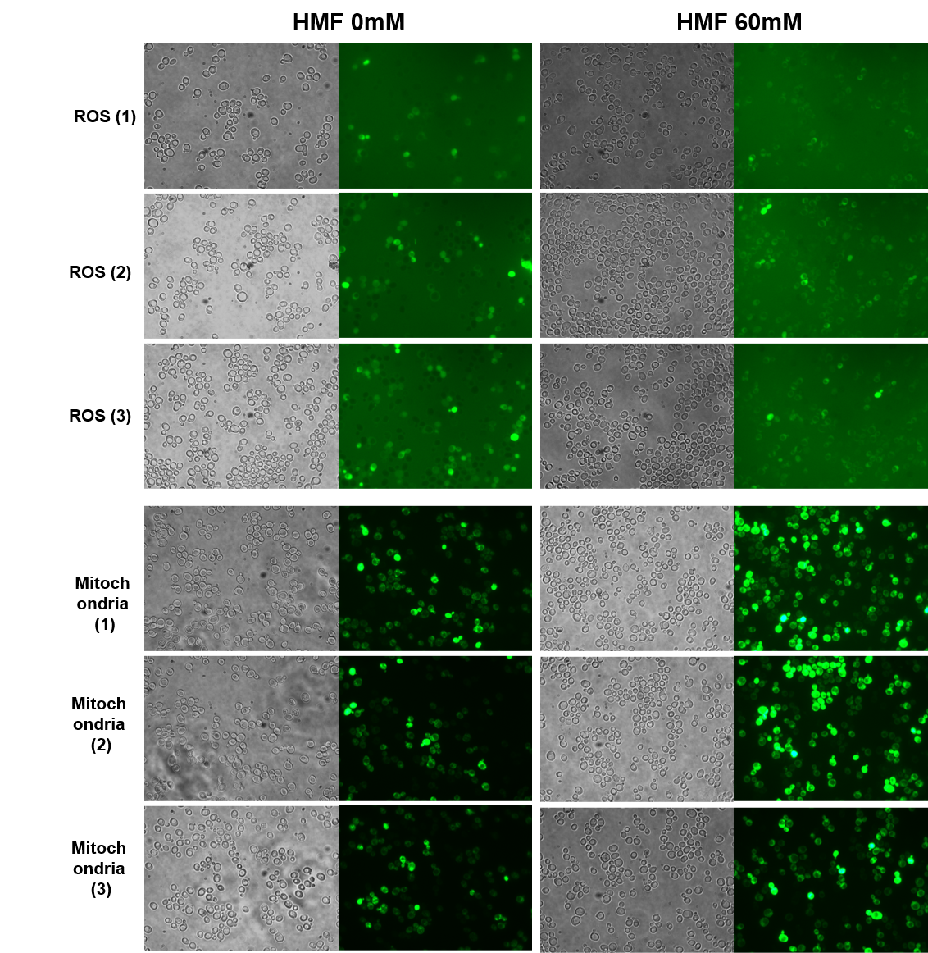

**B**

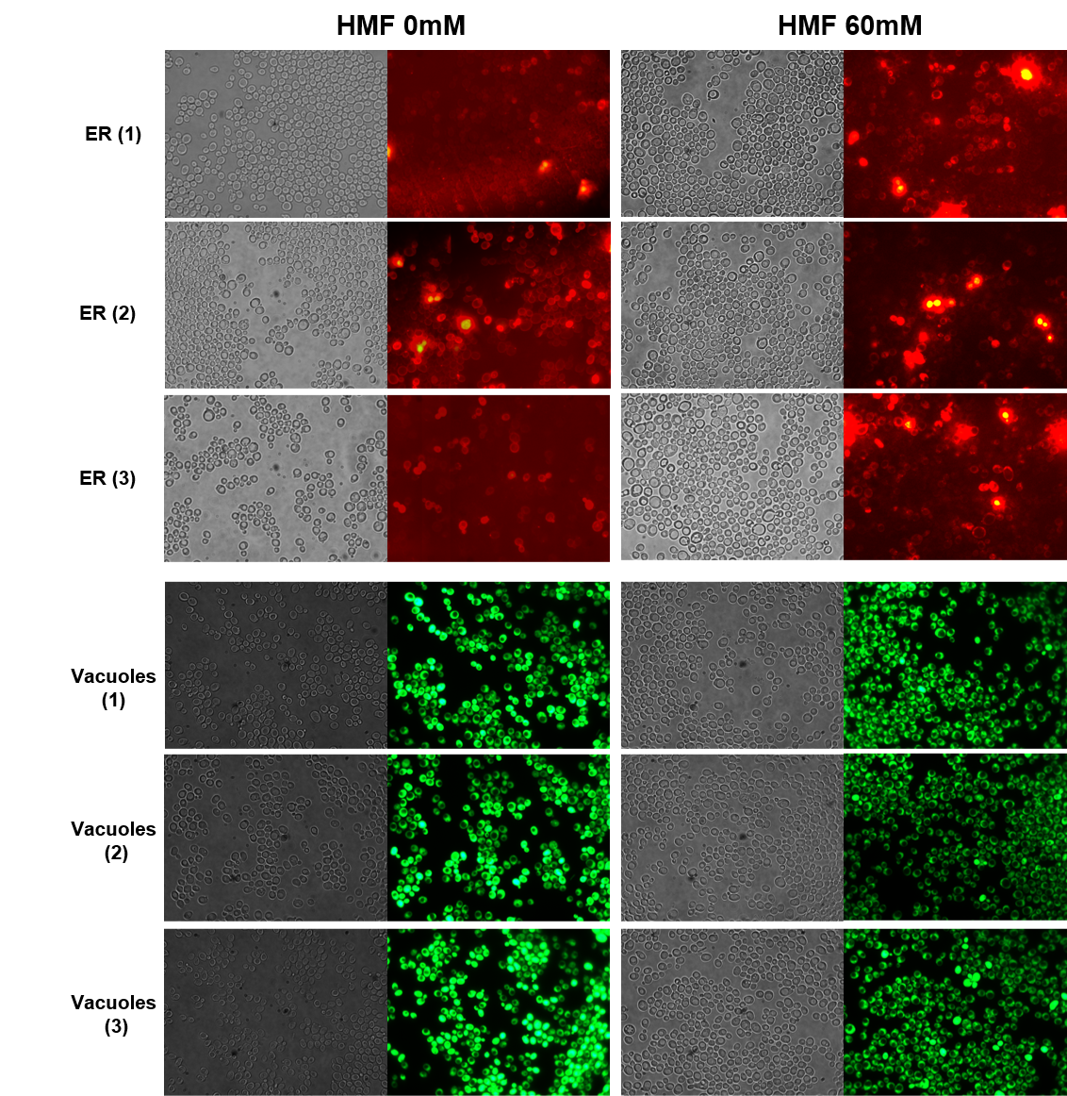

**C**

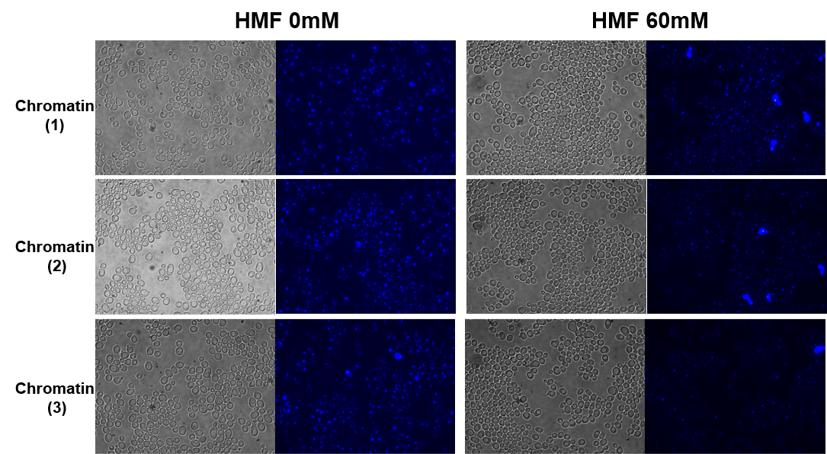

**Figure S2.** **The original image from the subcellular observation experiment with BY4741**

(**A**) Reactive Oxygen species and Mitochondria. (**B**) Endoplasmic reticulum and Vacuoles. (**C**) Chromatin.

**A**

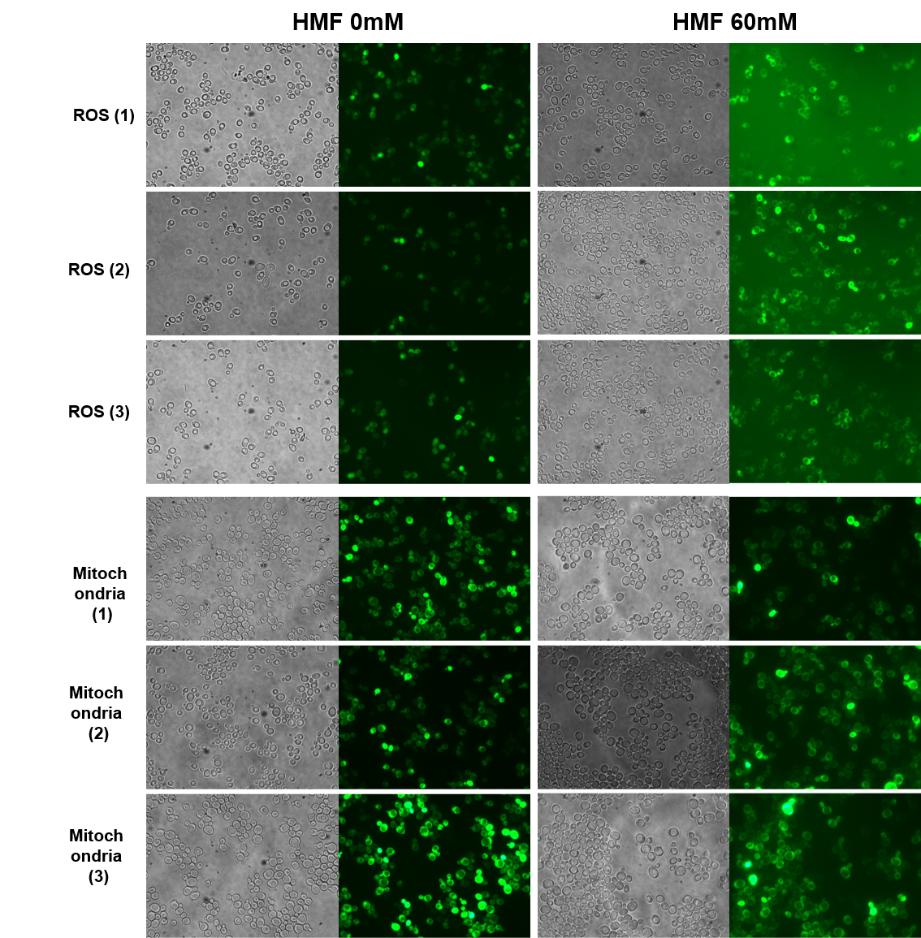

**B**

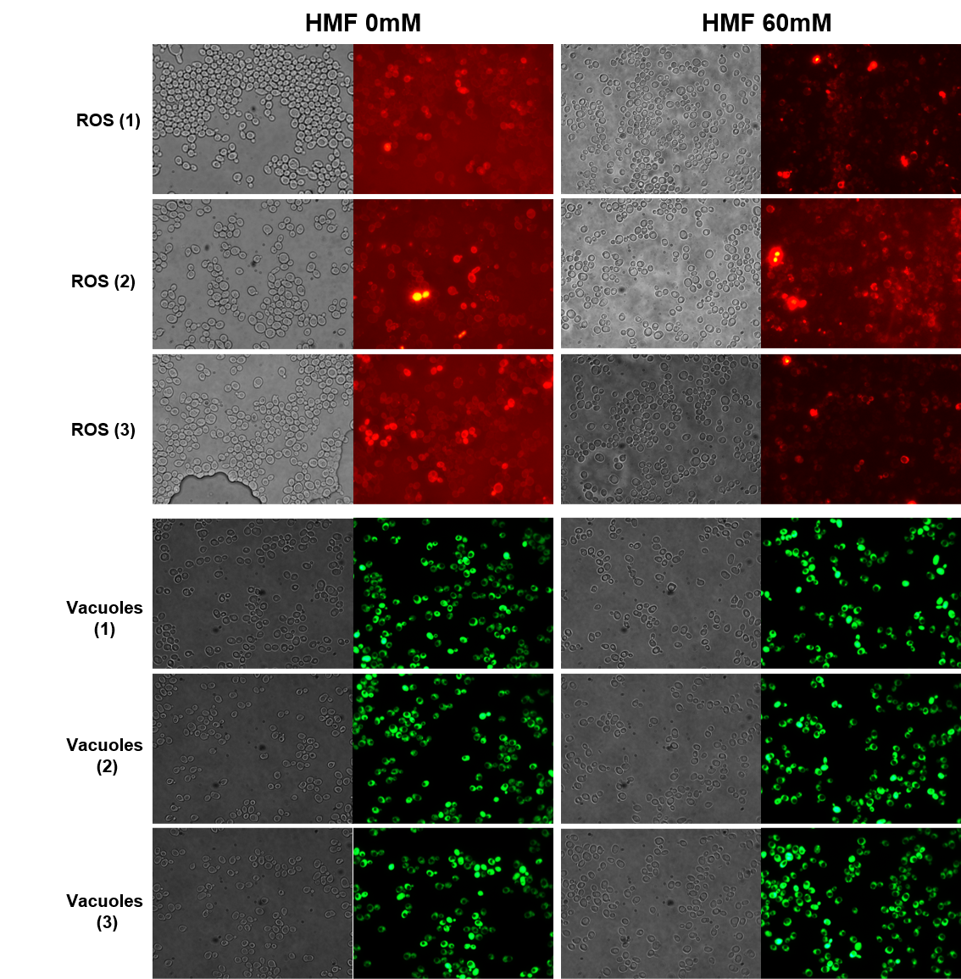

**C**

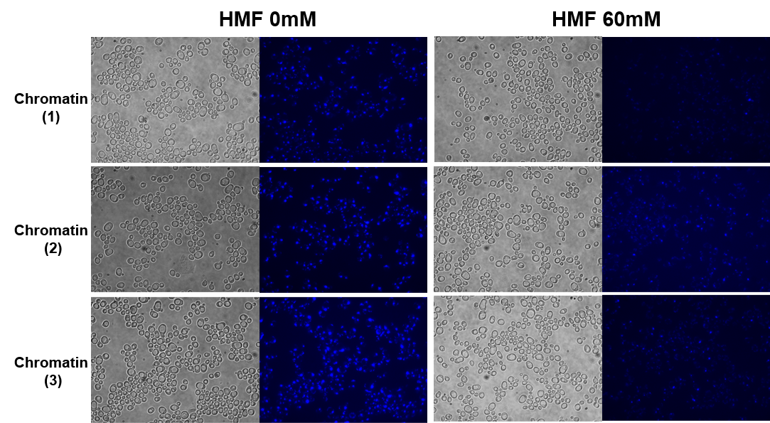 **Figure S3.** **The original image from the subcellular observation experiment with Siw14Δ**

(**A**) Reactive Oxygen species and Mitochondria. (**B**) Endoplasmic reticulum and Vacuoles. (**C**) Chromatin.